Toy Model #4b

The equations that define the simple Toy Model are described in Equations 1 and 2.

|  |  |  |
| --- | --- | --- |
|  | $$\frac{dΦ}{dt} =-βV-\frac{Φ^{3}}{3}+ Φ =L_{Φ}$$ $$\frac{dV}{dt} =βΦ+ α =L_{V}$$ | (1)  (2) |

Then with diffusion added Equations 1 and 2 become 3 and 4 as follows;

|  |  |  |
| --- | --- | --- |
|  | $$\frac{dΦ}{dt} =D\frac{d^{2}Φ}{{dx}^{2}} + L_{Φ}$$ $$\frac{dV}{dt} =D\frac{d^{2}V}{{dx}^{2}} + L_{V}$$ | (3)  (4) |

Where α and β are variable parameters

# Calculations

From the equations 1 and 2 it is possible to work out the Jacobian matrix

$$J= \left[\begin{matrix}{-Φ}^{2}+1 & -β \\ β & 0\end{matrix}\right]$$

Next to work out stability need to find the eigenvalues:

$$Det\left(λI-J\right)=0$$

$$λ= ± \sqrt{{-β}^{2}+{\left(\frac{Φ^{2}-1}{2}\right)}^{2}}- \frac{Φ^{2}-1}{2}$$

$$where Φ= -\frac{α}{β} at the fixed point$$

* Thus $β≠0,$
* for $α=β$ the $Re\left(λ\right)=0$,
* for $α<β$ the $Re\left(λ\right)>0$ therefore unstable and
* for $α>β$ the $Re\left(λ\right)<0$ therefore stable

$$-\frac{α}{β}=1$$

$$\frac{α}{β}=1$$

$$α$$

$$β$$

Unstable Region

Stable Region

$$β≠0$$

Figure 1: Relationship between alpha and beta

# Results 1

By choosing initial conditions of 3 and 2 for Ф and V respectively, fixing β=-1 and α={-1.5 : 1.5}, as per Figure 2, the following results were found:

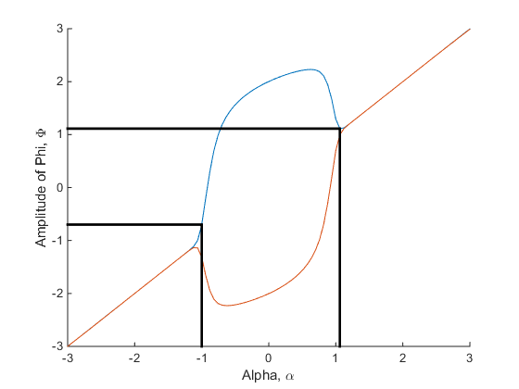

$$α$$

$$β$$

Figure 2-3: Visulasiation of alpha and beta passing through the unstable region and Biforcation diagram, holding β constant at -1 and varying α linearaly between {-1.5,1.5}

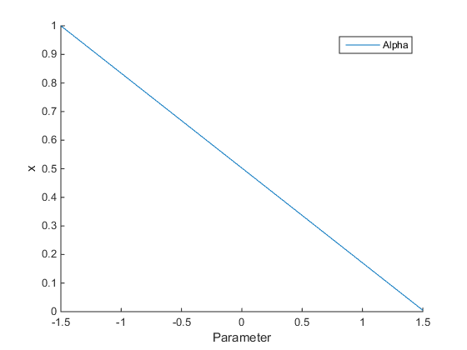

Figure 4: Alpha variation over space, holding β constant at -1

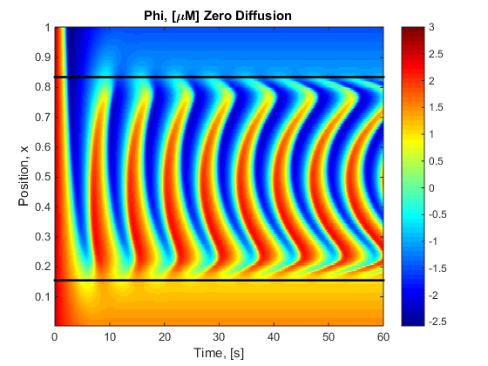 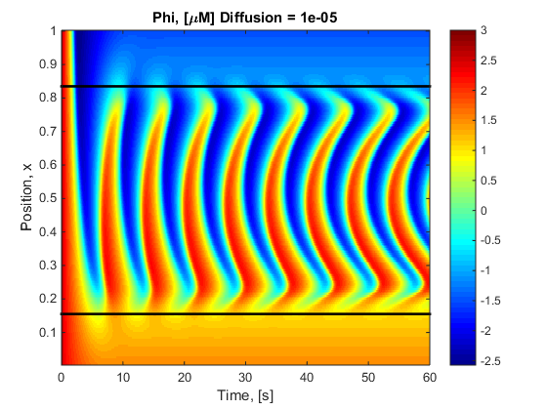

|  |  |  |
| --- | --- | --- |
| Figure 5: Holding β constant at -1 and varying α according to Figure 2 with zero diffusion |  | Figure 6: Holding β constant at -1 and varying α according to figure 2 with Simple diffusion |

# Results 2

The range of Alpha-Beta determine the different shapes appears in the unstable region results. For example choosing β=-1 and α={-1.5 : 1.5}:

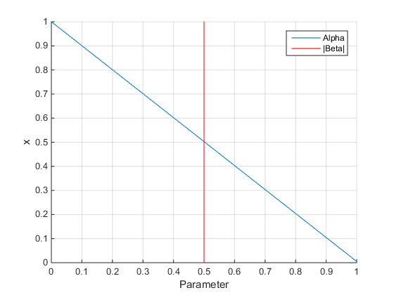

Figure 7: Alpha variation over space, holding β constant at -0.5

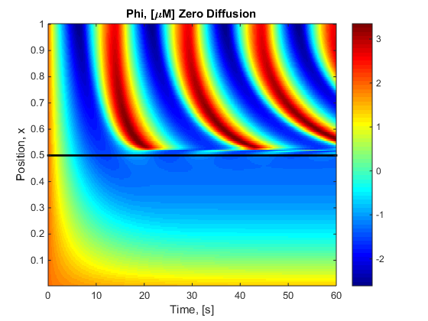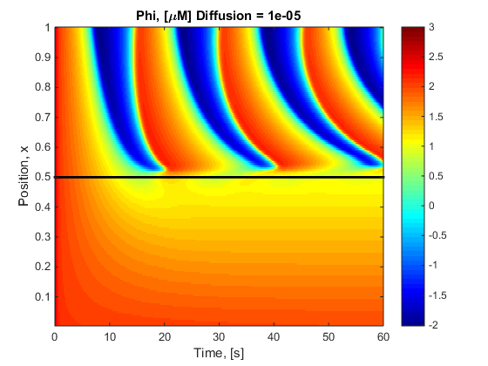

|  |  |  |
| --- | --- | --- |
| Figure 8: Holding β constant at -0.5 and varying α according to Figure 7 with zero diffusion |  | Figure 9: Holding β constant at -0.5 and varying α according to figure 7 with Simple diffusion |

# Results 3

Simulated over a long period of time

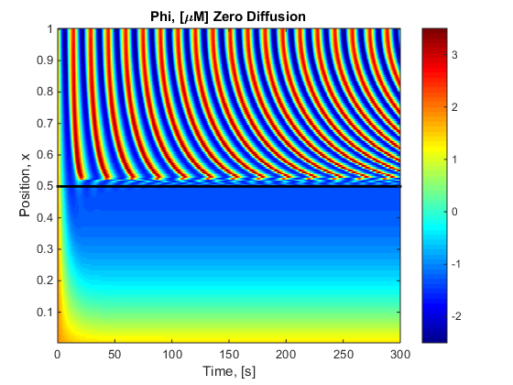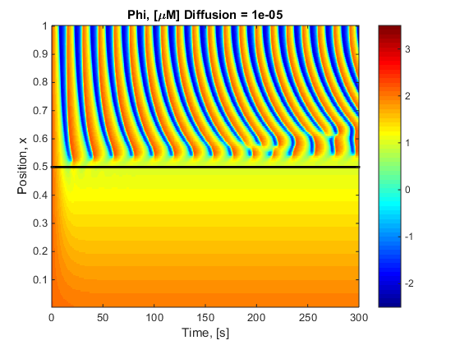

|  |  |  |
| --- | --- | --- |
| Figure 10: Holding β constant at -0.5 and varying α according to Figure 7 simulated for 300s with zero diffusion |  | Figure 10: Holding β constant at -0.5 and varying α according to Figure 7 simulated for 300s with Simple diffusion |

# Results 4

Effect of changing the diffusion constant, D.

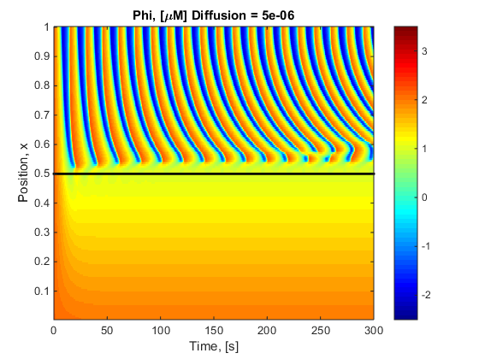

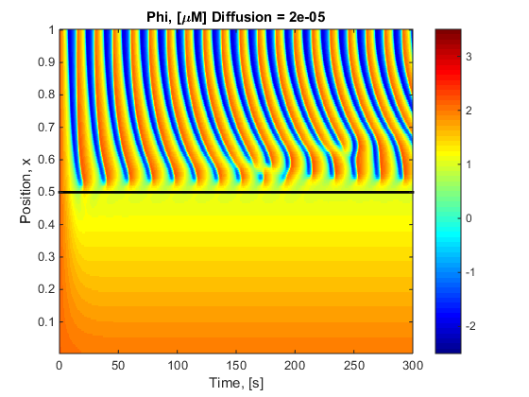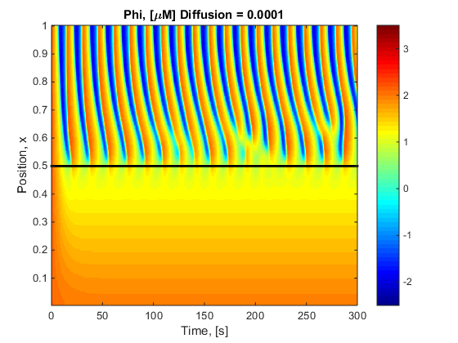

Figure 11-14: Holding β constant at -0.5 and varying α according to Figure 7 simulated for 300s with Simple diffusion changing 5e-6, 10e-6 (TR), 20e-6 (BL), and 100e-6 respectivly.

# Results 5

Try to make Phi, the “Calcium” always be positive. To do this the minimum value, after steady state, with zero diffusion was plotted. Changing both alpha and beta and only looking at the stable region.

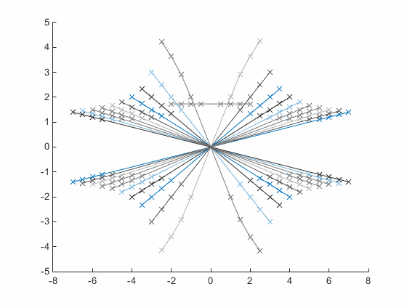

Β = -5

Β = 5

Β = 0 ignore

Figure 15: Relationship between alpha, beta and phi. Phi is on the y axis, alpha on the x axis and beta changes over lines {-5:0.5:5}

From figure 15 it can be deduced that to obtain a positive phi value alpha must be greater than zero for beta less than zero and vise versa. See in Figure 16.

Positive Phi Region

Positive Phi Region

$$α$$

$$β$$

Figure 15: Relationship between alpha, beta and phi.

After this was completed realised needed to also do the unstable region

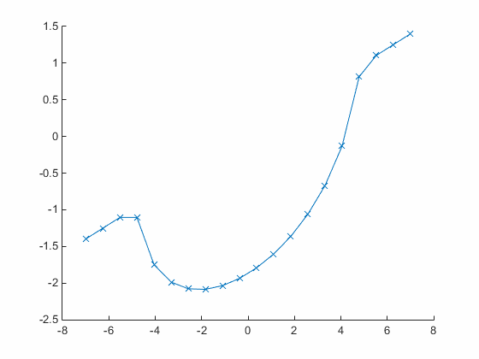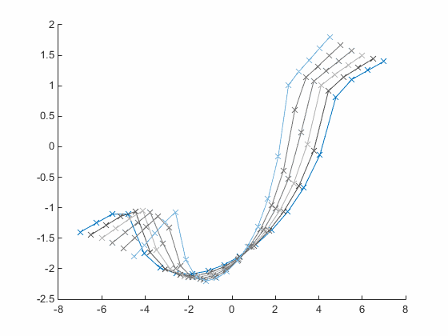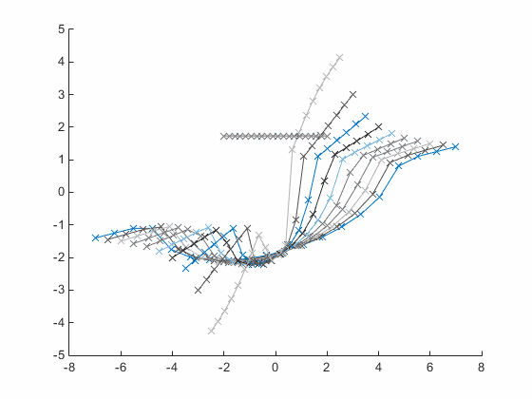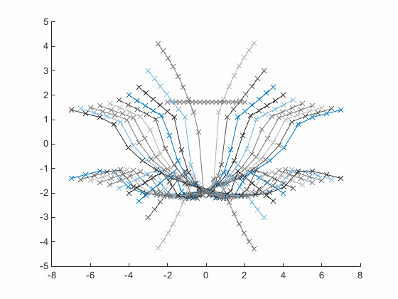

Figure 16-19: 4 snapshots of a gif. TL shows the minimum of the oscillatory region where the linear sections at the beginning and end are stable regions. TR Beta increases from -5 to 0 where in BL zero is the abnormal horizontal line. BR then completes the opposite from 0 to 5. Arrows indicate increasing beta.

# Discussion

* The shape of the unstable region depends on the alpha-beta combination
* Interaction between waves is seen in the diffusion after long periods of time and the interaction increases with diffusion constant.
* There is NO PROPERGATION into the previously stable region.
* Given figure 19, there is no suitable alpha-beta combination in which the oscillatory region stays positive.